**How to add Java Path to a config file in Talend**

Error Message: Failed to load the JNI shared library “C:\IBM\InformationServer/jdk32\jre\bin\j9vm\jvm.dll”.

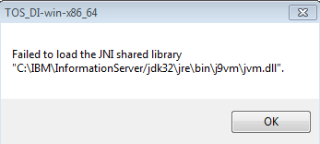

**Add the lines below in the configuration setting (.ini) file**

-vm

C:\Program Files\Java\jdk1.8.0_101\bin\javaw.exe

-vmargs

-Dosgi.requiredJavaVersion=1.8

**Reference**

How to find active Java Path with Windows

1. Search Configure Java
2. Open Configure Java 🡪 This will open Java Control Panel.
3. Go to the Java Tab and click View

